SilverScreen

Use-Case Specification: Register Account

Version 1.0

Revision History

|  |  |  |  |
| --- | --- | --- | --- |
| **Date** | **Version** | **Description** | **Author** |
| 31.10.2016 | 1.0 | Initial draft | Fabian Blatz, Marcel Borrmann |
| 03.11.2016 | 1.1 | Corrected Diagramm | Fabian Blatz |
| 15.11.2016 | 1.2 | Added Narration | Luca Bohr |
|  |  |  |  |

Table of Contents

[1. Use-Case Name 4](#_Toc465672043)

[1.1 Brief Description 4](#_Toc465672044)

[2. Flow of Events 4](#_Toc465672045)

[2.1 Basic Flow 4](#_Toc465672046)

[2.2 Alternative Flows 4](#_Toc465672047)

[3. Special Requirements 4](#_Toc465672048)

[4. Preconditions 4](#_Toc465672049)

[5. Postconditions 4](#_Toc465672050)

[6. Extension Points 4](#_Toc465672051)

Use-Case Specification: Register Account

# Use-Case Name

## Brief Description

Register Account is supposed to create a new account, which will be associated with Settings and the Movies someone enjoyed.

## MockUp

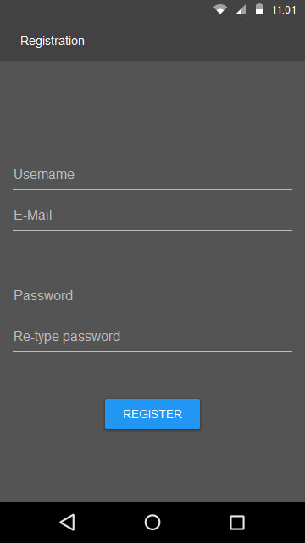 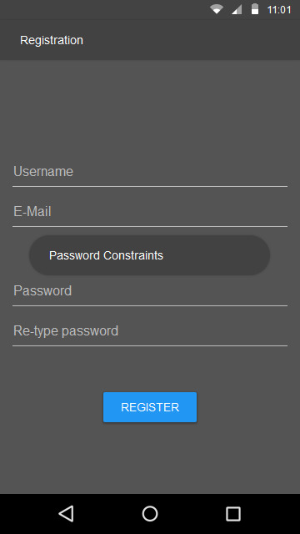 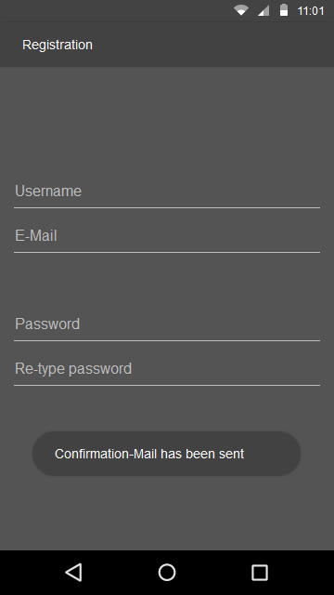

# Flow of Events

## Basic Flow

C:\Users\Fabian\Documents\Github\TINF15B4-LSMF\docs\Use-Cases\02_Register UC\UC_Register.png

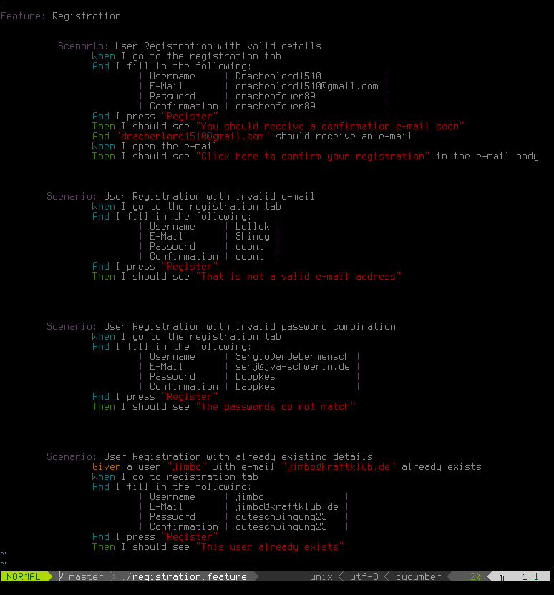

## Alternative Flows

There are no alternative Flows.

# Special Requirements

The phone needs an active internet connection and the user needs to have valid email address.

# Preconditions

None

# Postconditions

The user is registered and has been sent a activation email to activate the account.

# Extension Points

None